
Foundation University Islamabad
School of Science and Technology

Name: Hunaina Yasir Roll Number: 073
Subject: Programming Fundamentals Labs Section: B
LAB # 6

Tasks
6.1: Nested ‘for’ Statement (Drawing Patterns with Nested for Loops)
Write a program that uses for statements to print the following patterns separately, one below the other. Use for loops to generate the patterns. All asterisks (*) should be printed by a single statement of the form cout << '*'; (this causes the asterisks to print side by side).
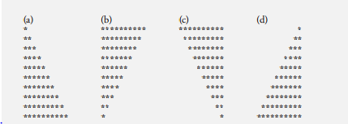
[Hint: The last two patterns require that each line begin with an appropriate number of blanks. Extra credit: Combine your code from the four separate problems into a single program that prints all four

A) SOURCE CODE:
#include <iostream>
using namespace std;
int main ()
{
cout << "Hunaina Yasir" << " " << "073";
cout << "\n";

for (int i=0 ; i<=10 ; i++ ) {
for (int j=0 ; j<=i ; j++) {
cout<<"*";
}
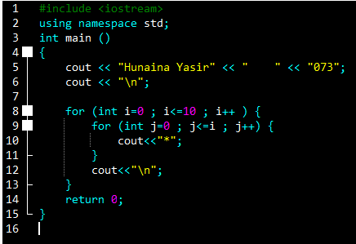
cout<<"\n";
}
return 0;
}

OUTPUT:
Hunaina Yasir 073
*
**
***
****
*****
******
*******
********
*********
**********
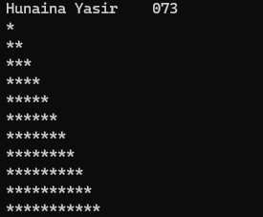
***********

B) SOURCE CODE:
#include <iostream>
using namespace std;
int main ()
{
cout << "Hunaina Yasir" << " " << "073";
cout << "\n";

for (int i=10 ; i>=0 ; i-- ) {
for (int j=0 ; j<=i ; j++) {
cout<<"*";
}
cout<<"\n";
}
return 0;
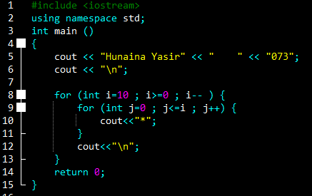
}

OUTPUT:
Hunaina Yasir 073
***********
**********
*********
********
*******
******
*****
****
***
**
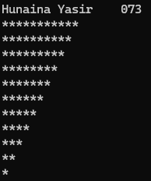
*
C) SOURCE CODE:
#include <iostream>
using namespace std;
int main ()
{
cout << "Hunaina Yasir" << " " << "073";
cout << "\n";

for (int i=0 ; i<=10 ; i++ )
{
for (int k=0 ; k<=i ; k++ )
{

cout<<" ";
}
for (int j=10 ; j>i ; j--)
{

cout<<"*";
}
cout<<"\n";
}
return 0;
}

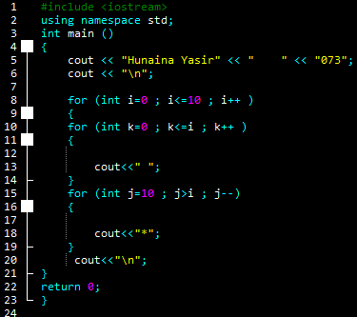
OUTPUT:
Hunaina Yasir 073
**********
*********
********
*******
******
*****
****
***
**
*
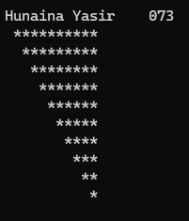
D) SOURCE CODE:
#include <iostream>
using namespace std;
int main ()
{
cout << "Hunaina Yasir" << " " << "073";
cout << "\n";

for (int i=0 ; i<=10 ; i++ )
{

for (int k=10 ; k>i ; k-- )
{

cout<<" ";
}
for (int j=0 ; j<i ; j++)
{

cout<<"*";
}
cout<<"\n";
}
return 0;
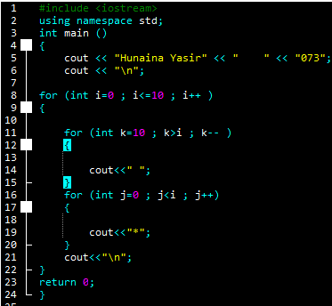
}

OUTPUT:
Hunaina Yasir 073

*
**
***
****
*****
******
*******
********
*********
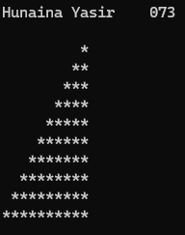
**********

6.2: Write a C++ program to generate a 4-digit number using nested for loops and displays each number from 0000 to 9999. You will have to use 3 nested ‘for’ loops to generate the output.
SOURCE CODE:
#include <iostream>
using namespace std;
int main ()
{
cout << "Hunaina Yasir" << " " << "073";
cout << "\n";

for (int thousands = 0; thousands <= 9; thousands++)
{
for (int hundreds = 0; hundreds <= 9; hundreds++)
{
for (int tens = 0; tens <= 9; tens++)
{
for (int ones = 0; ones <= 9; ones++)
{
cout << thousands << hundreds << tens << ones << endl;
}
}
}
}
return 0;
}

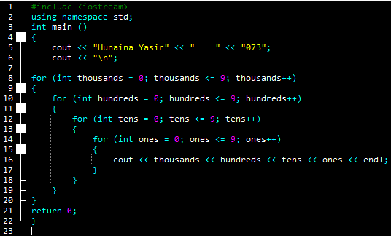
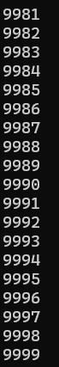
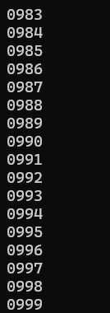
OUTPUT:
It prints from numbers 0983 to 9999.
Task 6.3: Write a C++ program to display a triangular pattern of numbers using a nested ‘for’ loop.
1
1 2
1 2 3
1 2 3 4
1 2 3 4 5
1 2 3 4 5 6
1 2 3 4 5 6 7
1 2 3 4 5 6 7 8
1 2 3 4 5 6 7 8 9
1 2 3 4 5 6 7 8 9 10
SOURCE CODE:

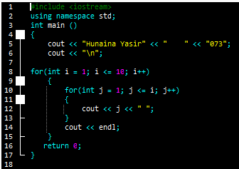
#include <iostream>
using namespace std;
int main ()
{
cout << "Hunaina Yasir" << " " << "073";
cout << "\n";

for(int i = 1; i <= 10; i++)
{
for(int j = 1; j <= i; j++)
{
cout << j << " ";
}
cout << endl;
}
return 0;
}

OUTPUT:
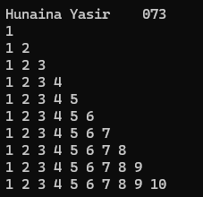
Hunaina Yasir 073
1
1 2
1 2 3
1 2 3 4
1 2 3 4 5
1 2 3 4 5 6
1 2 3 4 5 6 7
1 2 3 4 5 6 7 8
1 2 3 4 5 6 7 8 9
1 2 3 4 5 6 7 8 9 10

6.4: Repeat Task 6.1 using a nested ‘while’ loop.

A) SOURCE CODE:
#include <iostream>
using namespace std;
int main ()
{
cout << "Hunaina Yasir" << " " << "073";
cout << "\n";

int i = 0;
while (i <= 10)
{
int j = 0;
while (j <= i)
{
cout << "*";
j++;
}
cout << "\n";
i++;
}
return 0;
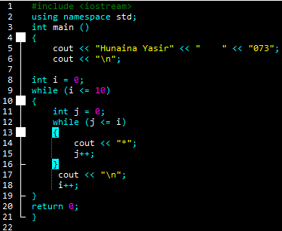
}

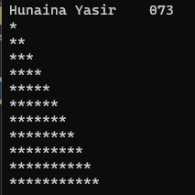
OUTPUT:
Hunaina Yasir 073
*
**
***
****
*****
******
*******
********
*********
**********
***********

B) SOURCE CODE:
#include <iostream>
using namespace std;
int main ()
{
cout << "Hunaina Yasir" << " " << "073";
cout << "\n";

int i = 10;
while (i >= 0)
{
int j = 0;
while (j <= i)
{
cout << "*";
j++;
}
cout << "\n";
i--;
}
return 0;
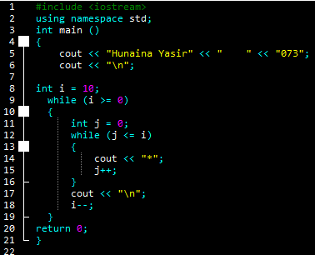
}

OUTPUT:
Hunaina Yasir 073
***********
**********
*********
********
*******
******
*****
****
***
**
*
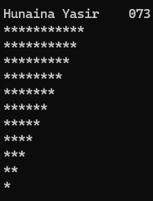
C) SOURCE CODE:
#include <iostream>
using namespace std;
int main ()
{
cout << "Hunaina Yasir" << " " << "073";
cout << "\n";

int i = 0;
while (i <= 10)
{
int k = 0;
while (k <= i)
{
cout << " ";
k++;
}
int j = 10;
while (j > i)
{
cout << "*";
j--;
}
cout << endl;
i++;
}
return 0;
}

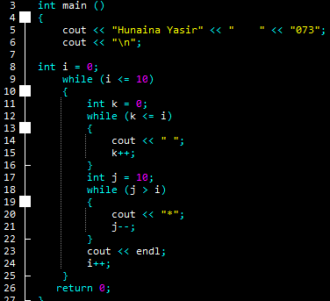
OUTPUT:
Hunaina Yasir 073
**********
*********
********
*******
******
*****
****
***
**
*
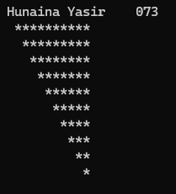
D) SOURCE CODE:
#include <iostream>
using namespace std;
int main ()
{
cout << "Hunaina Yasir" << " " << "073";
cout << "\n";

int i = 0;
while (i <= 10) {
int k = 10;
while (k > i)
{
cout << " ";
k--;
}
int j = 0;
while (j < i)
{
cout << "*";
j++;
}
cout << "\n";
i++;
}
return 0;
}
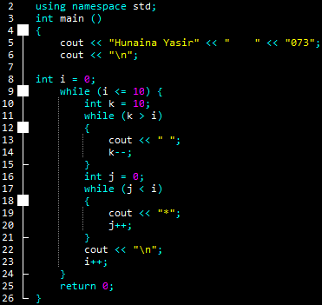
OUTPUT:
Hunaina Yasir 073

*
**
***
****
*****
******
*******
********
*********

**********

6.5: Repeat Task 6.2 using nested ‘while’ loop.
SOURCE CODE:
#include <iostream>
using namespace std;
int main ()
{
cout << "Hunaina Yasir" << " " << "073";
cout << "\n";

int thousands = 0;
while (thousands <= 9)
{
int hundreds = 0;
while (hundreds <= 9)
{
int tens = 0;
while (tens <= 9)
{
int ones = 0;
while (ones <= 9)
{
cout << thousands << hundreds << tens << ones << endl;
ones++;
}

tens++;
}

hundreds++;
}

thousands++;
}
return 0;
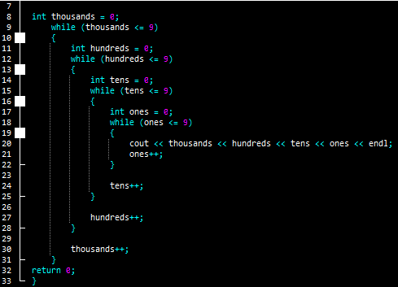
}



OUTPUT:
It prints from numbers 0983 to 9999.
Task 6.6: Write a C++ program to display a triangular pattern of numbers using a nested ‘while’ loop.
1
1 2
1 2 3
1 2 3 4
1 2 3 4 5
1 2 3 4 5 6
1 2 3 4 5 6 7
1 2 3 4 5 6 7 8
1 2 3 4 5 6 7 8 9
1 2 3 4 5 6 7 8 9 10
SOURCE CODE:
#include <iostream>
using namespace std;
int main ()
{
cout << "Hunaina Yasir" << " " << "073";
cout << "\n";

int i = 1;

while (i <= 10)
{
int j = 1;

while (j <= i)
{
cout << j << " ";
j++;
}

cout << endl;
i++;
}

return 0;
}
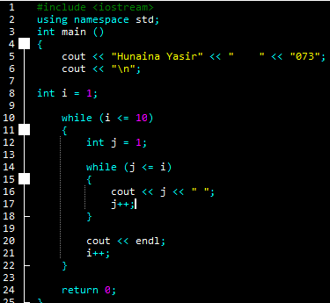
OUTPUT:
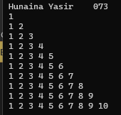
Hunaina Yasir 073
1
1 2
1 2 3
1 2 3 4
1 2 3 4 5
1 2 3 4 5 6
1 2 3 4 5 6 7
1 2 3 4 5 6 7 8
1 2 3 4 5 6 7 8 9
1 2 3 4 5 6 7 8 9 10

Task 6.7 Write a C++ program to display a triangular pattern using a nested ‘do-while’ loop.
*
int i = 0;
do {
int j = 0;
do {
cout << "*";
j++;
} while (j <= i);
cout << endl;
i++;
} while (i <= 10);
**
***
****
*****
******
*******
********
*********
**********
SOURCE CODE:

#include <iostream>
using namespace std;
int main ()
{
cout << "Hunaina Yasir" << " " << "073";
cout << "\n";

int i = 0;
do
{
int j = 0;
do
{
cout << "*";
j++;
}
while (j <= i);
cout << endl;
i++;
}
while (i <= 10);
return 0;
}
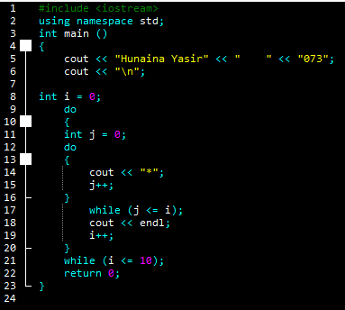
OUTPUT:
Hunaina Yasir 073
*
**
***
****
*****
******
*******
********
*********
**********
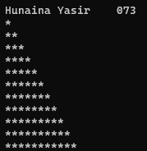
***********

6.8: Repeat Task 6.2 using nested ‘do-while’ loop.
SOURCE CODE:
#include <iostream>
using namespace std;
int main ()
{
cout << "Hunaina Yasir" << " " << "073";
cout << "\n";

int thousands = 0;
do {
int hundreds = 0;
do {
int tens = 0;
do {
int ones = 0;
do {
cout << thousands << hundreds << tens << ones << endl;
ones++;
} while (ones <= 9);
tens++;
} while (tens <= 9);
hundreds++;
} while (hundreds <= 9);
thousands++;
} while (thousands <= 9);

return 0;
}
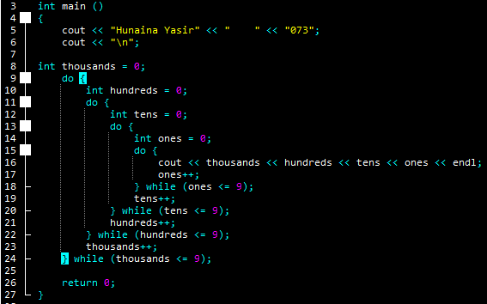


OUTPUT:
It prints from numbers 0983 to 9999.
6.9: Write a C++ program to display a triangular pattern of numbers using a nested ‘do-while’ loop.
1
1 2
1 2 3
1 2 3 4
1 2 3 4 5
1 2 3 4 5 6
1 2 3 4 5 6 7
1 2 3 4 5 6 7 8
1 2 3 4 5 6 7 8 9
1 2 3 4 5 6 7 8 9 10
SOURCE CODE:
#include <iostream>
using namespace std;
int main ()
{
cout << "Hunaina Yasir" << " " << "073";
cout << "\n";

int i = 1;
do
{
int j = 1;
do {
cout << j << " ";
j++;
} while (j <= i);

cout << endl;
i++;
} while (i <= 10);

return 0;
}
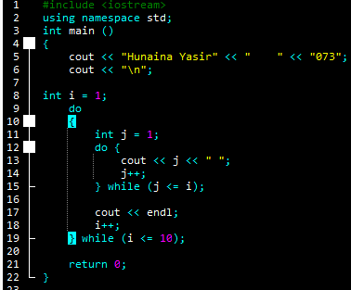

OUTPUT:
Hunaina Yasir 073
1
1 2
1 2 3
1 2 3 4
1 2 3 4 5
1 2 3 4 5 6
1 2 3 4 5 6 7
1 2 3 4 5 6 7 8
1 2 3 4 5 6 7 8 9
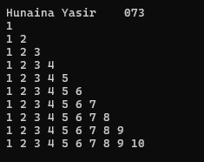
1 2 3 4 5 6 7 8 9 10

Exercises
6.1 Write a C++ program to read an odd integer from the user. If the user enters an even number, your program should decrement it by one to generate an odd number. Using this number as the number of rows, your program should then display a diamond of *s on the screen. Your program should have the following interface.

Enter an odd number: 5
*
***
*****
***
*

SOURCE CODE:
#include <iostream>
using namespace std;
int main ()
{
cout << "Hunaina Yasir" << " " << "073";
cout << "\n";
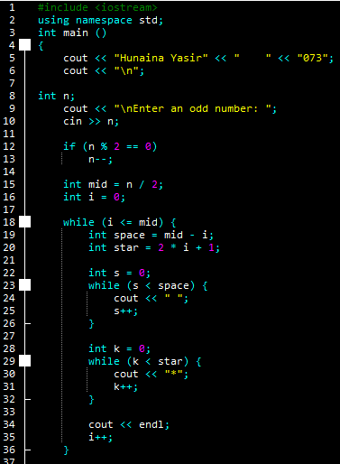
int n;
cout << "\nEnter an odd number: ";
cin >> n;

if (n % 2 == 0)
n--;

int mid = n / 2;
int i = 0;

while (i <= mid) {
int space = mid - i;
int star = 2 * i + 1;

int s = 0;
while (s < space) {
cout << " ";
s++;
}

int k = 0;
while (k < star) {
cout << "*";
k++;
}

cout << endl;
i++;
}

i = mid - 1;
while (i >= 0) {
int space = mid - i;
int star = 2 * i + 1;

int s = 0;
while (s < space) {
cout << " ";
s++;
}

int k = 0;
while (k < star) {
cout << "*";
k++;
}

cout << endl;
i--;
}

return 0;
}

OUTPUT:
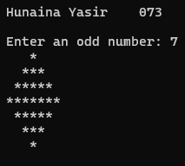
Hunaina Yasir 073

Enter an odd number: 7
*
***
*****
*******
*****
***
*

6.2 Write a C++ program to produce the following multiplication table. You must use nesting of control structures.
1 2 3 4 5 6 7 8 9 10
2 4 6 8 10 12 14 16 18 20
3 6 9 12 15 18 21 24 27 30
4 8 12 16 20 24 28 32 36 40
5 10 15 20 25 30 35 40 45 50
6 12 18 24 30 36 42 48 54 60
7 14 21 28 35 42 49 56 63 70
8 16 24 32 40 48 56 64 72 80
9 18 27 36 45 54 63 72 81 90
10 20 30 40 50 60 70 80 90 100
SOURCE CODE:
#include <iostream>
using namespace std;
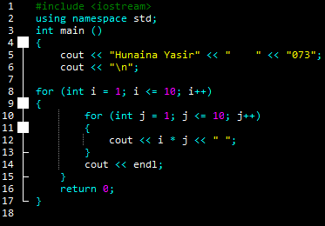
int main ()
{
cout << "Hunaina Yasir" << " " << "073";
cout << "\n";

for (int i = 1; i <= 10; i++)
{
for (int j = 1; j <= 10; j++)
{
cout << i * j << " ";
}
cout << endl;
}
return 0;
}



OUTPUT:
It prints from numbers 0983 to 9999.

6.3 Write a C++ program which reads in a number from user, stores it in a variable named ‘N’ and calculates the sum of powers using the following formula.
Sum = 1¹ + 2² + 3³ +……+N^{N}
Your program should have the following interface.
Enter a number: 4
Sum = 1^1 + 2^2 + 3^3 + 4^4 = 288

SOURCE CODE:
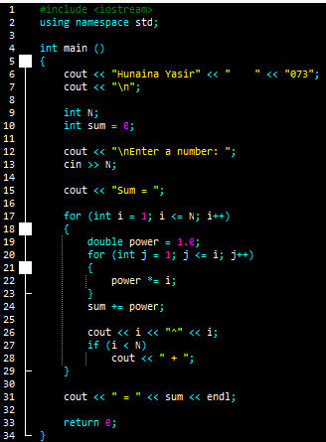
#include <iostream>
using namespace std;

int main ()
{
cout << "Hunaina Yasir" << " " << "073";
cout << "\n";

int N;
int sum = 0;

cout << "\nEnter a number: ";
cin >> N;

cout << "Sum = ";

for (int i = 1; i <= N; i++)
{
double power = 1.0;
for (int j = 1; j <= i; j++)
{
power *= i;
}
sum += power;

cout << i << "^" << i;
if (i < N)
cout << " + ";
}

cout << " = " << sum << endl;

return 0;
}

OUTPUT:
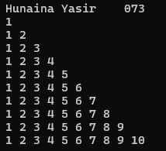
Hunaina Yasir 073
1
1 2
1 2 3
1 2 3 4
1 2 3 4 5
1 2 3 4 5 6
1 2 3 4 5 6 7
1 2 3 4 5 6 7 8
1 2 3 4 5 6 7 8 9
1 2 3 4 5 6 7 8 9 10

